NHS 111 Interoperability Specification
Amendment History:
Version | Date | Amendment History
0.1 | 12/05/2010 | First draft for comment
0.2 | 14/05/2010 | Updated with NF Req & Comments form Rory
0.3 | 02/06/2010 | Updated after first round of feedback from suppliers
1.0 | 23/06/2010 | Approved with minor revisions & CaseID Addition in acknowledgment.
1.1 | 20/08/2010 | Updated WSDL.Uplift from v1.1 to v1.3:  Addition of “AcknowledgmentStatus” in the response objects for AddCase & UpdateCase &  Policy tags Added for mandatory use of addressing.  Updated XSD Uplift from V2.3 to V2.31 :  Addition of targetnamespace to reflect nhspathways as unique identifier.  Case change from PathwaysContentVersion → pathwaysContentVersion  Clarifications on the following:  Mandatory Use of WSA Core 1.0  Removal of Ambiguity on “AuthHeader”  Removal of Ambiguity on “Username”
1.2 | 14/04/2011 | Updated XSD Uplift from V2.31 to V2.4  Addition of Prefix fields for all phone numbers in the schema.  Increase in Length of phone number field to 23 characters.  Addition of value “CMSLookup” for questiontype field.  Restricting skillset values to T1,T2,T3 & T4 by enumeration.  Restricting transfercode/type values to T1,T2,T3&T4 by enumeration.  Update to the document to reflect distinction in headers for Synchronous and Asynchronous communication.
1.3 | 04/05/2011 | Removed references to NHS Pathways to align with government policy.  Changed document name to NHS 111 Interoperability Specification.
1.4 | 24/06/2011 | Added Specification for handling Repeat callers
1.41 | 19/07/2011 | Refined repeat caller requirement after feedback
1.42 | 04/08/2011 | Final draft before publishing after more feedback
1.43 | 11/08/2011 | Added new webservices AddCaseEnhanced to facilitate transfer of multiple cases in case of repeatcallers.  Updated CheckCase Webservice to send schemaVersion along with each pathwaysCaseStructure.  Updated CheckCase Webservice to split the firstLineOfAddress in two sub fields.
2.0 | 19/01/2011 | Extensive uplift at end of pilots  Message payload specifications enhanced and moved to separate pack.  Web Services transport details replaced with reference to standard ITK Web Services.  Added port information for firewall configuration  Added Diagram of Interoperability Landscape  See Appendix B for further details of changes
2.1 | 20/03/2012 | Added port information for firewall configuration  Added Diagram of Interoperability Landscape  Minor corrections to grammar
Forecast Changes:
Anticipated Change | When
Reviewers:
This document must be reviewed by the following:<author to indicate reviewers>
Name | Signature | Title / Responsibility | Date | Version
Ian Smith | Ian Smith | Pathways Dev Manager |  | 1.0
Rory Davidson | Rory Davidson | NHS 111 Lead Architect |  | 1.1,1.2,1.4
Tony Yates | Tony Yates | NHS 111 Technical SME |  | 1.1,1.2,1.4,2.0
James Woods | James Wood | DHID Head if infrastructure security | 26/01/2012 | 2.0
Tim Davey | Tim Davey | Technical Architect | 26/01/2012 | 2.0,2.1
David Barnet | David Barney |  | 26/01/2012 | 2.0,2.1
Damian Murphy | Damian Murphy | Senior Assurance Manager | 26/01/2012 | 2.0,2.1
Approvals:
This document must be approved by the following:
Name | Signature | Title / Responsibility | Date | Version
Tony Yates | Tony Yates | NHS 111 Technical SME (DH) | 26/01/2012 | 2.0,2.1
Tim Davey | Tim Davey | Lead Architect (DHiD) | 26/01/2012 | 2.0,2.1

Distribution:
This document is to be distributed to the 111 programme. The programme will “own” the document and distribute as it deems fit.
Document Status:
This is a controlled document. Whilst this document may be printed, the electronic version maintained in FileCM is the controlled copy. Any printed copies of the document are not controlled.
Related Documents:
Ref no | Doc Reference Number  (TRUD package id) | Title | Version
[1] | NHS 111 Version: 1.0; Status: - RC2 | The 111 messaging payload specifications
[2] | nhs_itkcore_2.0.0_20110725000001 | The ITK core specifications, including web services transport
[3] | nhs_itkaccreditation_2.0.0_20111212000001 | Details of the ITK accreditation process

Glossary of Terms:
List any new terms created in this document. Mail the NPO Quality Manager to have these included in the master glossary above [1].
Term | Acronym | Definition

Contents

1 Purpose 6
2 Scope 6
3 Solution Overview 7
4 Messaging Requirements 8
4.1 MSG.1 Payload specifications 8
4.2 MSG.2 ITK Distribution Envelope 8
4.3 MSG.3 ITK Messaging Architecture 8
4.4 MSG.4 ITK Web Services Transport 8
4.5 MSG.5 Full ITK Compliance 9
4.6 MSG.6 Security based on TLS Mutual Authentication 10
4.7 MSG.7 Direct, synchronous connection 10
5 Non-functional Requirements 11
5.1 NFR.1 Flexible Architecture 11
5.2 NFR.2 Support for Multiple Versions of Message Definitions 11
5.3 NFR.3 Availability 11
5.4 NFR. 4 Open Standards 11
5.5 NFR.5.001 Response Times 11
6 Appendix A: Future Enhancements 12
7 Appendix B: Evolution from v1.43 13

Purpose
The purpose of this document is to provide an interoperability specification to be used for the exchange of pathways information for transfer of care between the 111 service providers.

Scope
The scope of this document is to lay down the foundations for specific message interactions between the 111 system suppliers.

Solution Overview
This section provides a summary view to allow readers a familiarisation with the key aspects which will aid in the understanding of the document contents.
The solution covers the mechanism for the transfer of triage information between the NHS 111 call handling organisations as well as to the various health service providers including ambulance trusts, Out Of Hours (OOH) services and the Repeat Caller Service.
The overall NHS 111 solution allows the call handler to direct for different forms of medical care and to make this available at the most relevant point of care for the patient based on the results of triage. This can be in the form of an ambulance dispatch, referring to OOH / urgent care services or simply providing medical information amongst other outcomes.
This document focuses on the technical elements of information exchange & specifies a standard mechanism to incorporate this implementation. The solution architecture can be seen in Figure 1.
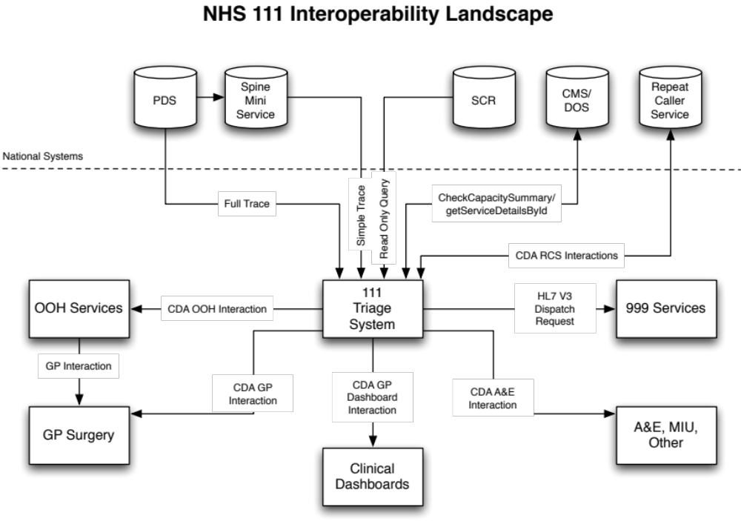
Figure 1

Messaging Requirements
Note that this section makes extensive reference to ITK Specifications. These may be obtained from the TRUD download service, see https://www.uktcregistration.nss.cfh.nhs.uk. (Further assistance with TRUD may be obtained from the Data Standards and Products Helpdesk at datastandards@nhs.net .
The relevant TRUD packages are:
- NHS 111 Version: 1.0; Status: - RC2 Domain Message Specification under NHS MESSAGE SPECIFICATIONS – the 111 messaging payload specifications
- nhs_itkcore - the ITK core specifications, including web services transport
- nhs_itkaccreditation – details of the ITK accreditation process

MSG.1 Payload specifications
Message payloads MUST be conformant with the 111 message definitions
These are specified in NHS 111 Version: 1.0; Status: - RC2 Domain Message Specification under NHS MESSAGE SPECIFICATIONS.

MSG.2 ITK Distribution Envelope
Messages MUST wrap the 111 message in an ITK Distribution Envelope.
Usage of the Distribution Envelope is also specified in nhs_itkcore.

MSG.3 ITK Messaging Architecture
All 111 messaging implementations MUST be compliant with the ITK Messaging Architecture specification.
The document “NPFIT-ELIBR-AREL-DST-0433.01 ITK 2.0 Messaging Architecture v2.0” (see nhs_itkcore pack) provides further detail about use of the Distribution Envelope, and other generic aspects of ITK message handling (eg versioning, reliable handling). The requirements in this document MUST be complied with.
(Note that for the purposes of initial 111 go-live then the messaging security requirements (COR-SEC-01 through COR-SEC-05) may be considered to be adequately covered by the approach based on TLS Mutual Authentication that is described in requirement MSG.6 below).

MSG.4 ITK Web Services Transport
All 111 messaging implementations MUST be compliant with the ITK Web Services Transport Specification.
The document “NPFIT-ELIBR-AREL-DST-0430.02 ITK 2.0 Web Services Transport Specification v3.0” (see nhs_itkcore pack) provides further detail about the ITK web services transport. The requirements in this document MUST be complied with, with the exception of the requirements listed below which MAY be omitted for initial 111 go-live:
- The following requirements may be excepted for initial 111 go-live as they are not relevant as they relate to messaging patterns that are not currently needed by 111:
- WS-PAT-02: Toolkit Web Services MUST use the Asynchronous Invocation style for Pattern 1 services where this is specified
- WS-PAT-03: Toolkit Web Services MUST use the Synchronous Invocation Pattern for Pattern 2 services
- WS-PAT-04: The SimpleMessageResponse MUST contain simple acknowledgement of a Pattern 2 request
- The following requirements are security related, and may be excepted for initial 111 go-live, as an alternative, simplified, security approach has been defined for 111 (see MSG.6 below):
- WS-SEC-03: Toolkit Implementations MUST sign the message timestamp
- WS-SEC-07: Toolkit Implementations MUST be able to authenticate a requestor’s identity
- WS-SEC-08: Toolkit Implementations MUST be able to authorise a service request, based on the Service and the Requestor’s identity
- WS-DSC-15: The timestamp element of the SOAP Header MUST be signed
- WS-DSC-05: Canonicalization method MUST be present in the signature
- WS-DSC-06: PKI certificates MUST be used for message signing
- WS-DSC-17: PKI certificates MUST be from a recognised CA
- WS-DSC-18: Toolkit middleware and applications MUST preinstall all CA root certificates that are listed in the Microsoft Trusted Root Certificate Store.
- WS-DSC-19: Toolkit middleware and applications MUST preinstall the NHS CA Root Certificate
- WS-DSC-20: Toolkit middleware and applications MAY preinstall the Root Certificate from other CAs that they choose to trust
- WS-DSC-21: Toolkit middleware and applications MUST verify the certificate Thumbprint against an approved list
- WS-DSC-09: Detached signatures SHOULD be used if XML Signature is utilised
- WS-DSC-10: KeyInfo element MUST use SecurityTokenReference
- WS-DSC-14: The X509 certificate MUST be included in the BinarySecurityToken element

MSG.5 Full ITK Compliance
All 111 messaging implementations SHOULD gain full “ITK Application” Accreditation, including support for the 111 messaging payload bundle.
In practice this will involve, in addition to the above, implementing the remaining requirements in the “itk_core” pack – see “NPFIT-ELIBR-AREL-DST-0422.02 ITK 2.0 Specifications Overview v2.0” for details of the additional ITK requirements modules that are relevant to this.
It is recognised that the tight timescales for 111 implementation mean that it may not be possible for all implementations to gain full compliance prior to initial 111 go-live. In this case, the supplier MUST provide a self-assessment listing those ITK requirements that they believe they will not meet at initial go live, and MUST agree in writing a date by which they commit to rectify this and gain full ITK Application Accreditation.

MSG.6 Security based on TLS Mutual Authentication
The 111 service requires “any-to-any” connections between nodes: call handlers and service providers. Connections are made under the direction of information in the 111 directory of service. The size of the handler and provider population, and the requirement to be able to add handlers and providers with a minimum of disruption, argues against reliance on firewalls to restrict connection access. To use firewalls, would require significant reconfiguration across the estate each time a handler or provider is added.

An alternative is to open a single firewall port on each 111 node and rely on certificates and mutually-authenticated TLS to secure connections. This works by requiring that all 111 nodes have a certificate which is identifiable, and trustworthy as, belonging to a bona fide 111 node. On receipt, a connection will only be accepted if it is secured with a certificate that is trustworthy as being from another 111 node. Sites are configured to use this simply by installing the certificate authority certificates, in their platform. Port 1879 has been agreed as the port that will be used by all parties for 111 messaging.

Such trustworthiness is assured by the “policy” which guards the issuance of a certificate to a 111 site. At the time of initial rollout, there is no such established policy which completely assures the identity of a 111 node – delivery of that policy is dependent on a PKI project with a longer delivery timescale than NHS 111.

As an interim, Spine certificates will be used. Spine certificates are signed by a nationally-recognised Certificate Authority, and protected by a policy which identifies sites for connection to Spine. On their own, Spine certificates do not identify a site as a 111 node. However, to create a Spine certificate the Fully Qualified Domain Name (FQDN) and associated IP address of the site must be provided, and the policy enforces this. Therefore, by controlling access to an aspect of the FQDN, the 111 programme ensures that the certificate issued by Spine, identifies the holder as a 111 node.

This will be done by placing all 111 nodes under the subdomain “oneoneone.nhs.uk” – control of that subdomain provides the additional 111-specific policy around the issuance of Spine certificates, that makes a 111-specific certificate trustworthy as such.

On receipt of a connection request, an NHS 111 endpoint will only accept the connection if it is secured by a Spine-issued certificate that has a CN containing an FQDN of the form nodename.oneoneone.nhs.uk. In more detail these checks comprise of:
· Full certificate path validation and revocation check by both client and server (client and server stated in the context of the TLS Protocol but in essence, both parties perform verification and validation of each others presented certificates)
· Check the validity of the dates within the certificates presented
· Check that the certificate being presented is one which has been issued to a 111 node (i.e. has a CN containing an FQDN of the form nodename.oneoneone.nhs.uk)
· Check the issuer of the presented certificate and that should include checking of Authority Key ID and Subject Key ID

Note that using the FQDN to provide additional identification for a 111 endpoint is a tactical solution and MAY be subject to changes in future policy regarding DNS or use of the 111 services. For example use of the FQDN check might become redundant at such time as 111 security policy is handled via the processes that protect issuance of certificates against a specific 111 sub CA. To avoid undue impact on deployed systems, vendors MUST allow the FQDN checks to be configured such that they can be “turned off” without the need to deploy changed code.

MSG.7 Direct, synchronous connection
To be able to fulfil the requirements for 111 messaging the following properties of the interaction must exist:
- The interface MUST be synchronous from the perspective of an HTTPS connection. The request and response are communicated over the same HTTPS connection and the user must be conscious of the message response in real time.
- The service caller and provider MUST NOT communicate via an intermediary.

MSG.8 Endpoint Addressing
Messages to service providers (eg Out of Hours, Ambulance) will be addressed to the service provider’s endpoint for receiving 111 messages. This service provider endpoint MUST be as retrieved from the 111 Directory of Service (DoS). The location of the DoS itself MUST be a configurable item.
Messages to the Repeat Caller Database will be addressed to a single well-known endpoint. The details of this Repeat Caller Database endpoint MUST be a configurable item.

Non-functional Requirements
The following requirements are expected to be implemented by all suppliers involved in the NHS 111 pilots. This list is likely to grow during the development of the NHS 111 pilot solution.

NFR.1 Flexible Architecture
The system SHOULD be designed flexibly, so as to accommodate change.
The systems and interfaces comprising the NHS Care Record Services will change over time, as new policies and functionality are introduced, and the operational environment evolves. This will require that suppliers are able to modify, activate and deactivate system and user interfaces, and the operational behaviour of the system, or parts thereof.

NFR.2 Support for Multiple Versions of Message Definitions
The system MUST be designed in such a way as to support multiple versions of message definitions as receiver and sender of NHS 111 messages to and from other suppliers/organisations.

NFR.3 Availability
The Availability of the system MUST be appropriate for the environment in which it is being deployed, taking into consideration its intended usage.
The method for calculating the target Availability of the system MUST be defined, and the required target Availability MUST be documented.
The actual Availability of the system MUST be monitored.
Failure to meet the required target Availability of the system must be addressed through service improvements.

NFR. 4 Open Standards
Suppliers SHOULD adopt Open Standards wherever possible for the development, testing and deployment of accredited systems that will connect to any of the Spine Services.
Across the NHS, Open Standards will be applied where applicable, and suppliers are likely to accommodate change most easily if they have adhered to this requirement.

NFR.5.001 Response Times
The system MUST enable users to work efficiently.
System design must take account of the user experience and ensure that the introduction of NHS 111 functionality enhances, rather than degrades, the user experience.
Systems should make use of appropriate current technology and best practice, and take into consideration the expected response time characteristics of using web services.

Appendix A: Future Enhancements

- Usage of same address lookup data as used in the 999 for the purposes of locating Northings and Eastings consistent with ambulance service data.

Appendix B: Evolution from v1.43
This document (v2.0) represents a significant evolution from the previous v1.43 of this specification. This appendix therefore provides traceability, explaining how and why the specification has evolved into this latest version
- Purpose
No change
- Scope
This section simplified. The previous version referred to future activity in terms of further generalising the message content - this has now been accomplished.
- Solution Overview
No change
- Requirements
This section has been substantially rewritten, with the aim of aligning with ITK specifications and best practices. In more detail:
4.1 Overview
This described various fundamental details of using web services and WSDL - this material is given a similar treatment in the Chapters 1-3 of the ITK Web Services Transport Specification, and is therefore no longer needed.
A number of specific points were made regarding the acceptable messaging patterns for 111 usage, and these are retained in Requirement “MSG.7 Direct, synchronous connection”
4.2 Web Services Message Header
This previously described how to use WS-* specifications to construct a SOAP Header. This duplicates similar work in the ITK Web Services Transport Specification, and is therefore no longer needed. Whilst there are some small differences, the ITK Web Services specifications are essentially very similar - but have been subject to more extensive testing and proving, and also represent a move to a consistent approach to Web Services implementation throughout the NHS.
4.3 Web Services Methods
These gave an overview of the message payloads, and have been replaced by equivalent overview information in the new, separate message specifications pack
4.4 Web Method Authentication
There is an important change here, with the username / password SOAP Headers being replaced by the use of mutually authenticated TLS to secure the connection. This is significantly more secure than the previous password-based approach, and has the additional advantage of being managed via infrastructure configuration rather than custom coding.
4.5 Additional Web Services Parameters
These are no longer needed and so this section is deleted.
- SchemaVersion - this is now handled in a standard way by the ProfileID attribute of the Distribution Envelope
- ServiceType - this was never actually used and is covered in the new payload design
4.6 Web Method Acknowledgement Status
This section previously described a set of bespoke error handling codes which were carried in a bespoke tag defined in wsdl. This is now replaced by standardised SOAP Fault handling of errors, as defined in the ITK specifications.
See “NPFIT-ELIBR-AREL-DST-0430.02 ITK 2.0 Web Services Transport Specification v3.0”, requirement WS-FDT-02, which defines the following standard ITK SOAP Fault error codes:
- 1000 = Invalid Message (There is something incorrect with the message structure or content – a bug fix for the sender)
- 2100 = Processing Error (Retryable) (A processing error that may be retry-able – eg system temporarily down)
- 2200 = Processing Error (Not Retryable) (A processing error that is not retry-able – eg a programming bug in the integration infrastructure code)
- 3000 = Access Denied (A security problem)

These therefore replace the previous “rejection” response codes as follows:
- REJECT_AUTHENTICATION_FAILURE => SOAP Fault, error code 3000
- REJECT_BADLY_FORMED => SOAP Fault, error code 1000
- REJECT_UNKNOWN_VERSION => SOAP Fault, error code 1000
- REJECT_OTHER => SOAP Fault, error code 2100 or 2200, depending on nature of error
The “success” response codes then become implicit in the return of the expected response message:
- SUCCESS_COMPLETE => Expected response message returned
- SUCCESS_NO_RECORDS_FOUND => Expected response message returned, containing an empty recordset
- SUCCESS_PARTIAL
- SUCCESS_RECORDS_ENCLOSED

- Non Functional Requirements
No Change
- Appendix A - Walkthrough Scenarios
This is now replaced by the examples in the separate messaging specifications pack
- Appendix B: NHS 111 Case Schema & Documentation
This is no longer relevant as these documents are replaced by the separate messaging specifications pack
- Appendix C: Future Enhancements
This is now Appendix A of this document. Many of the envisaged future enhancements have now been accomplished, and are therefore removed from the list.

